Physics Assignment

Name: Adhula A

21110001

AI & DS SECTION A

**Question 1**

import numpy as np

import matplotlib.pyplot as plt

freq=50

interval=1/freq

st_time=0

end_time=20

sig1_freq = 2

sig2_freq = 4

sig3_freq = 6

time = np.arange(st_time,end_time,interval)

amp1=np.sin(2*np.pi*sig1_freq*time)

amp2=np.sin(2*np.pi*sig2_freq*time)

amp3=np.sin(2*np.pi*sig3_freq*time)

figure , axis = plt.subplots(4,1)

plt.subplots_adjust(hspace=3)

axis[0].set_title('Frequency hz')

axis[0].plot(time,amp1)

axis[0].grid(True, which='both')

axis[0].set_xlabel('Time')

axis[0].set_ylabel('Amplitude')

axis[1].set_title('Freuqency 4hz')

axis[1].plot(time,amp2)

axis[1].grid(True, which='both')

axis[1].set_xlabel('Time')

axis[1].set_ylabel('Amplitude')

axis[2].set_title('Frequency 6hz')

axis[2].plot(time,amp3)

axis[2].grid(True, which='both')

axis[2].set_xlabel('Time')

axis[2].set_ylabel('Amplitude')

amp=amp1+amp2+amp3

axis[3].set_title('Resultant frequency')

axis[3].plot(time,amp)

axis[3].grid(True, which='both')

axis[3].set_xlabel('Time')

axis[3].set_ylabel('Amplitude')

plt.show()



Question 2

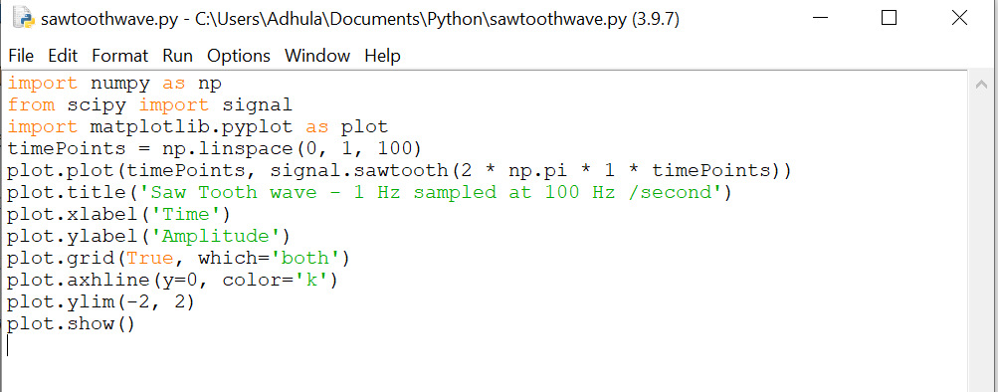

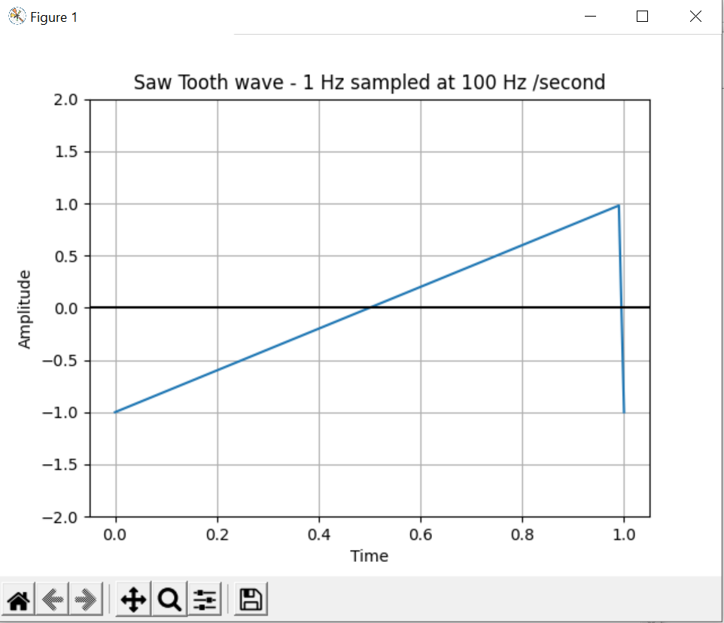

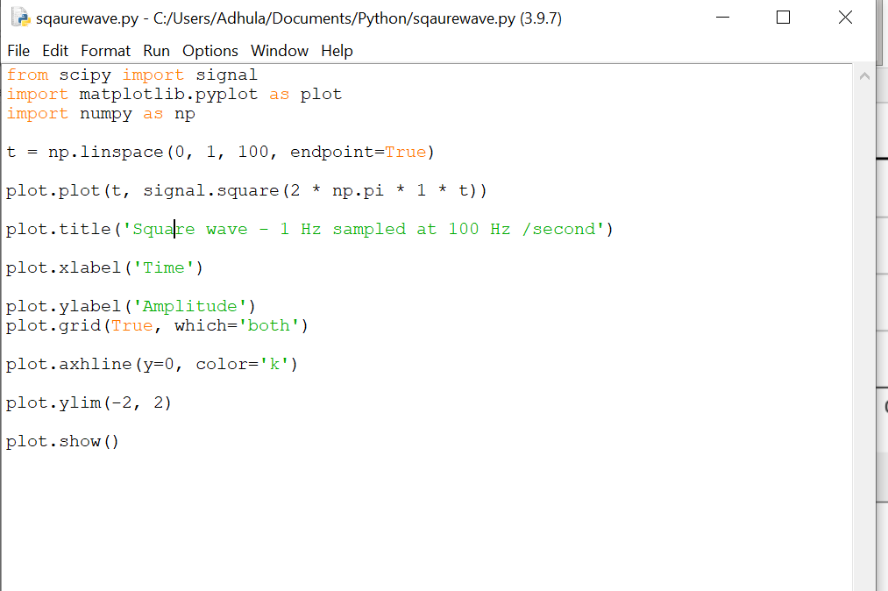

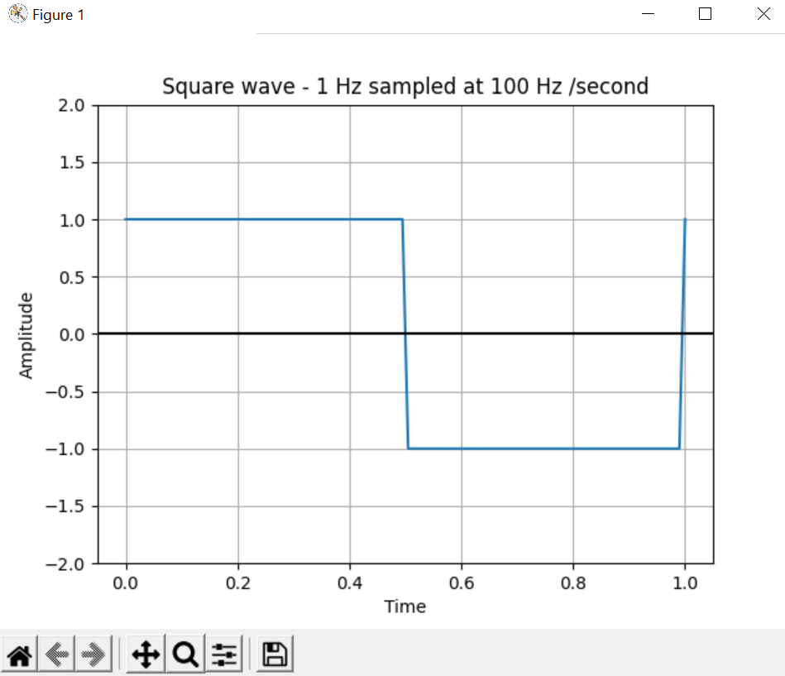

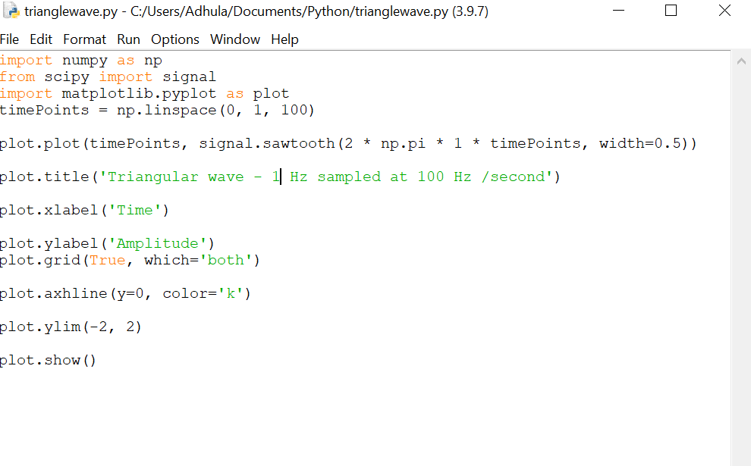

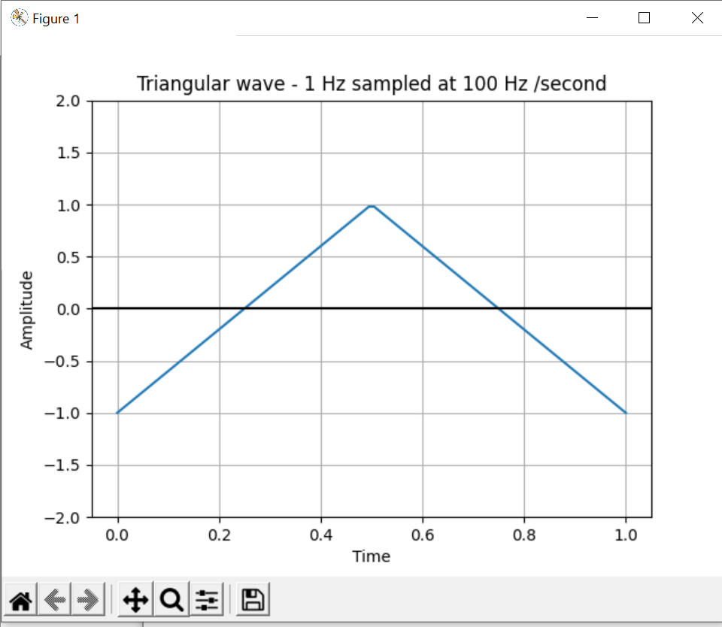

Question 3

Numpy library in Python consist of fft.fft() function which returns one dimensional Fourier transform with efficient fast Fourier transfer algorithm whereas the fft() function in MATLAB uses the fast Fourier transform algorithm to compute Fourier transform of data.